Test Case: tc001_SPX_Dev5_Crear_Requisicion_Spot_Tipo_Cobro_CC
Step 1 - Enter username and password and click to button Enter : Credentials Entered
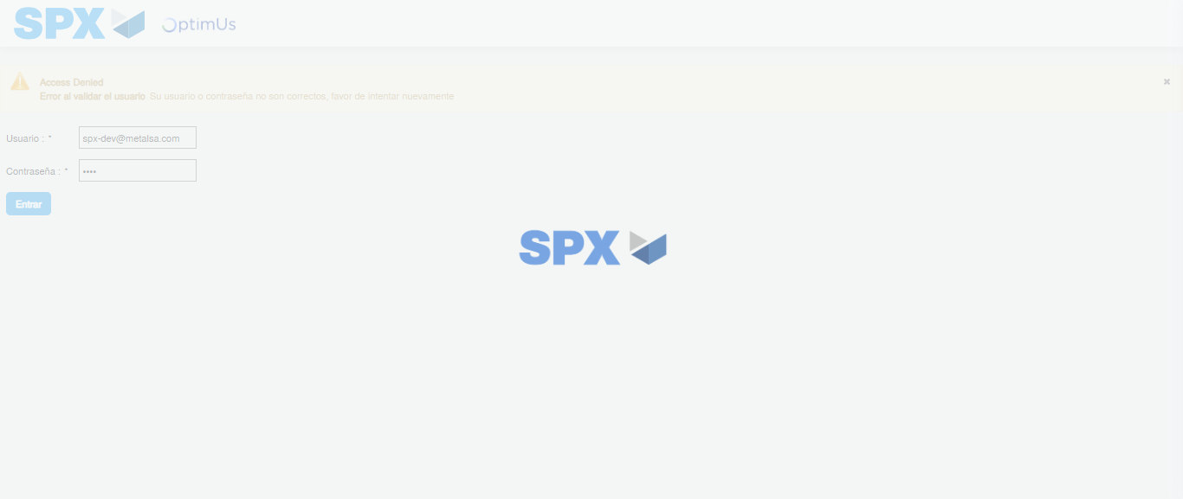Image file-name: QC_Testing-tc001_SPX_Dev5_Crear_Requisicion_Spot_Tipo_Cobro_CC-1782255405069

Step 2 - Select to UEN and Access to Spot Buy Requisitions : UEN Correctly selected and Correct access
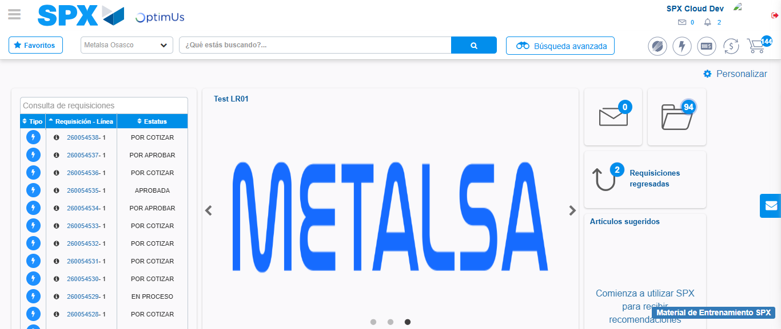Image file-name: QC_Testing-tc001_SPX_Dev5_Crear_Requisicion_Spot_Tipo_Cobro_CC-1782255431204

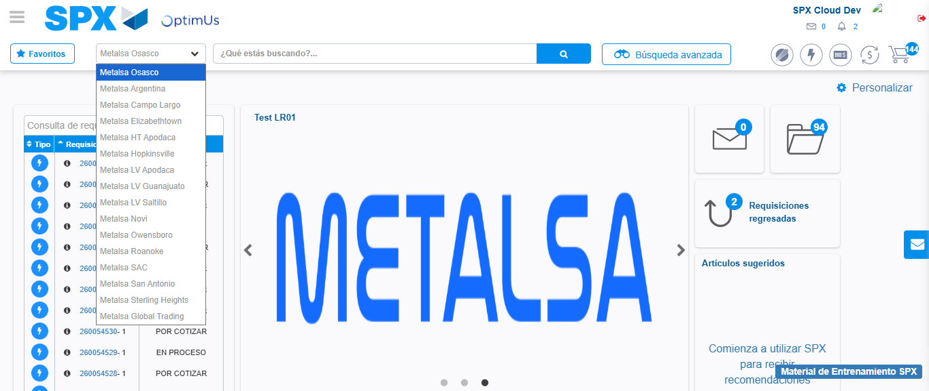Image file-name: QC_Testing-tc001_SPX_Dev5_Crear_Requisicion_Spot_Tipo_Cobro_CC-1782255433849

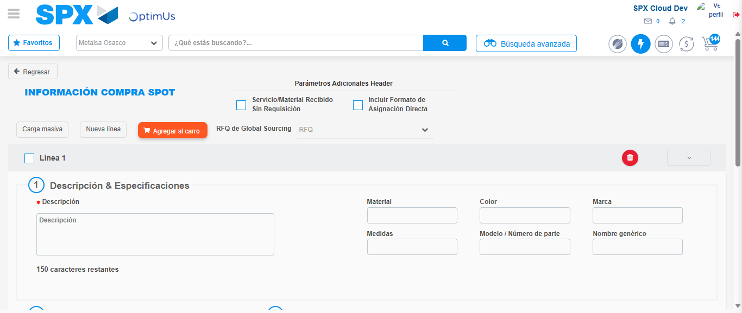Image file-name: QC_Testing-tc001_SPX_Dev5_Crear_Requisicion_Spot_Tipo_Cobro_CC-1782255453555

Step 3 - Data Capture Spot Buy Requisition : Data captured correctly
Image file-name: QC_Testing-tc001_SPX_Dev5_Crear_Requisicion_Spot_Tipo_Cobro_CC-1782255453815

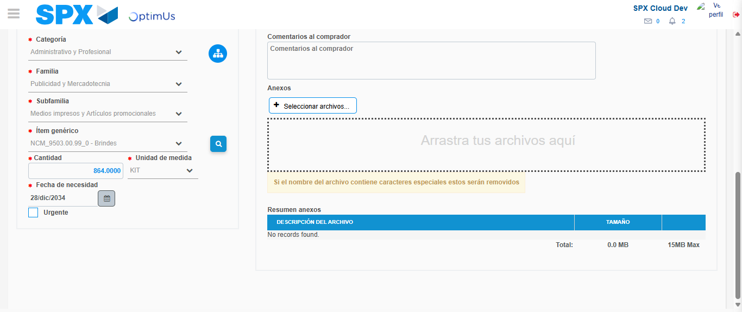Image file-name: QC_Testing-tc001_SPX_Dev5_Crear_Requisicion_Spot_Tipo_Cobro_CC-1782255465742

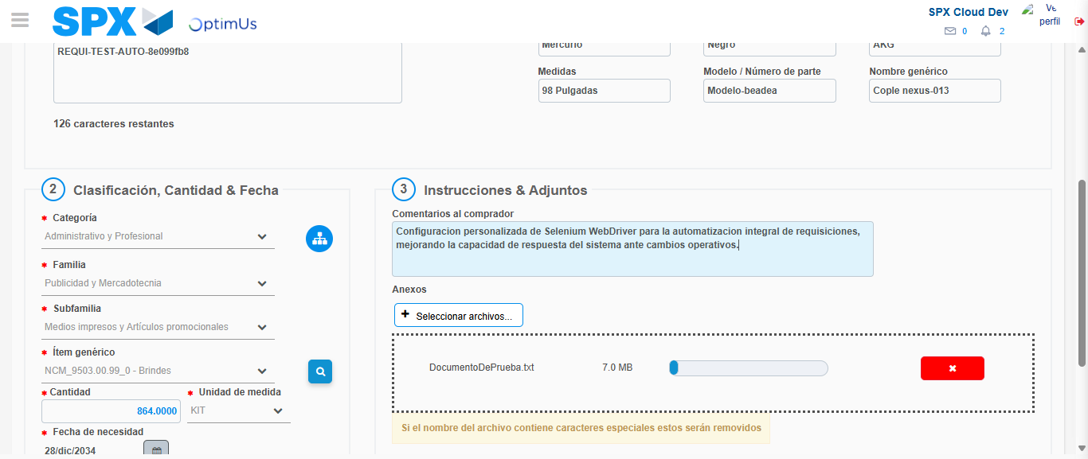Image file-name: QC_Testing-tc001_SPX_Dev5_Crear_Requisicion_Spot_Tipo_Cobro_CC-1782255466539

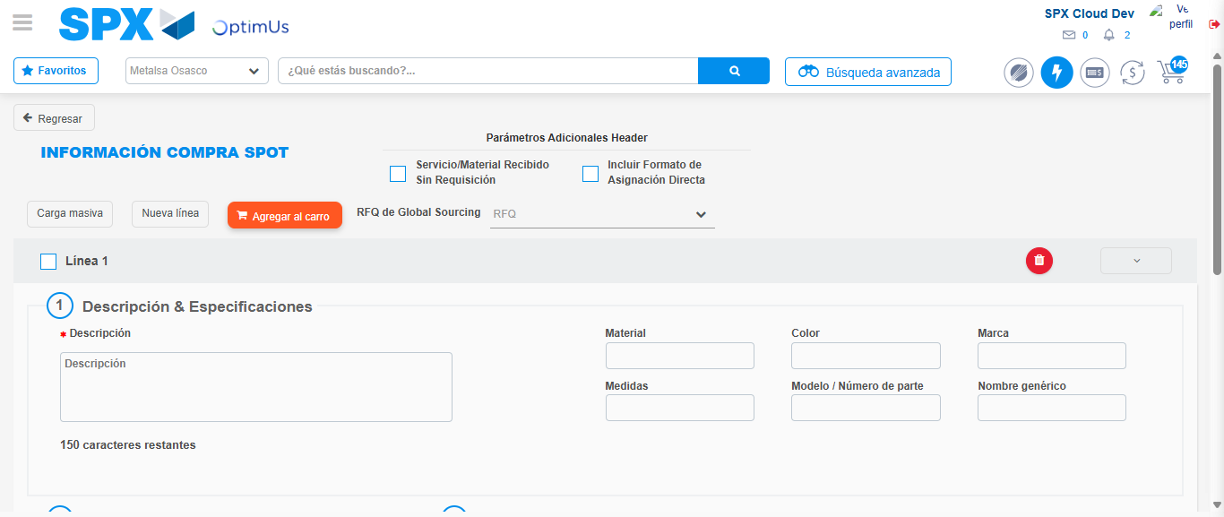Image file-name: QC_Testing-tc001_SPX_Dev5_Crear_Requisicion_Spot_Tipo_Cobro_CC-1782255473038

Step 7 - Return to Main Page SPX : Return to Main Page SPX
Image file-name: QC_Testing-tc001_SPX_Dev5_Crear_Requisicion_Spot_Tipo_Cobro_CC-1782255431204

Image file-name: QC_Testing-tc001_SPX_Dev5_Crear_Requisicion_Spot_Tipo_Cobro_CC-1782255433849

Image file-name: QC_Testing-tc001_SPX_Dev5_Crear_Requisicion_Spot_Tipo_Cobro_CC-1782255453555

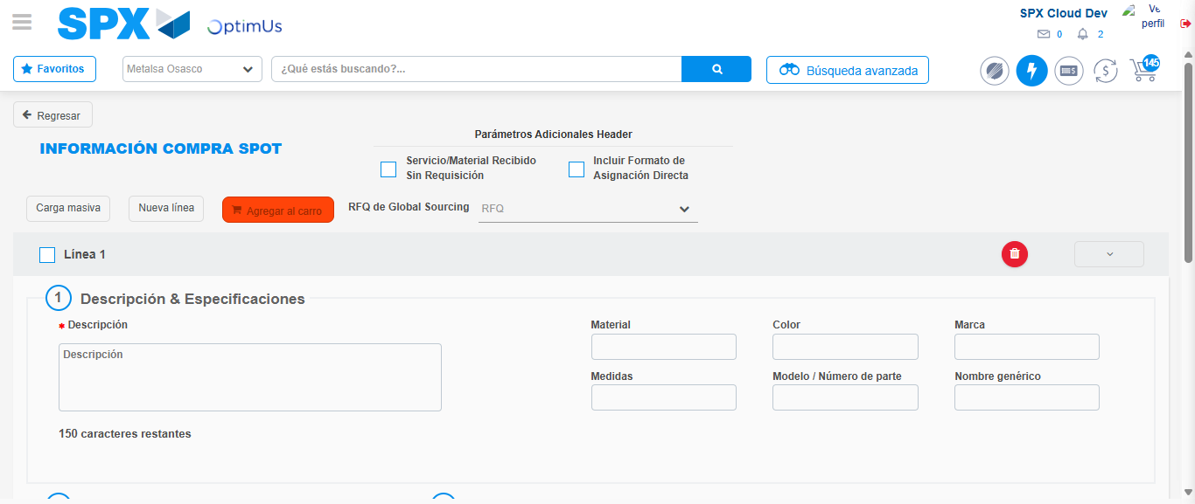Image file-name: QC_Testing-tc001_SPX_Dev5_Crear_Requisicion_Spot_Tipo_Cobro_CC-1782255475262

Image file-name: QC_Testing-tc001_SPX_Dev5_Crear_Requisicion_Spot_Tipo_Cobro_CC-1782255475435

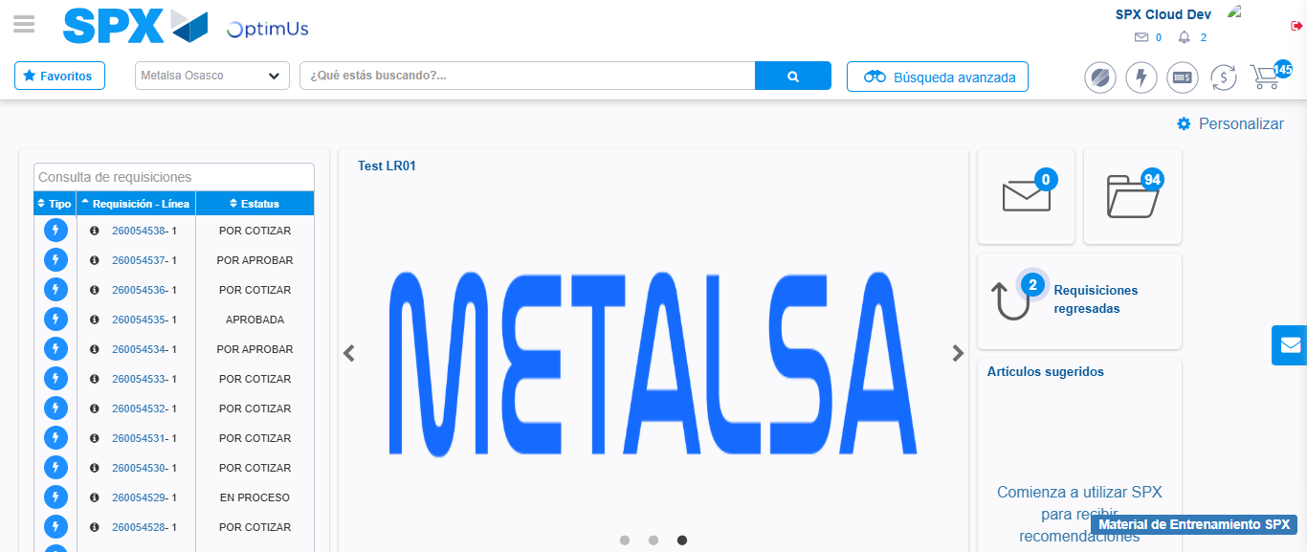Image file-name: QC_Testing-tc001_SPX_Dev5_Crear_Requisicion_Spot_Tipo_Cobro_CC-1782255496493

Step 8 - Log Out : Log Out SPX
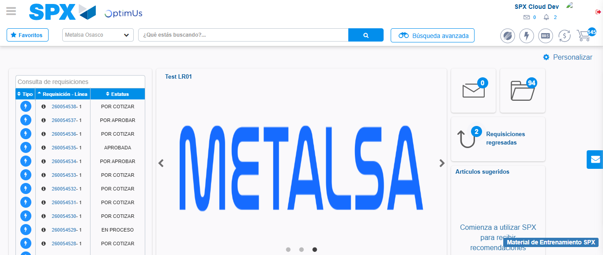Image file-name: QC_Testing-tc001_SPX_Dev5_Crear_Requisicion_Spot_Tipo_Cobro_CC-1782255496767

